Exercise 2: Finite Element Method

# Task 5: Error norms

Hint: gradedMesh = false

|  |  |  |
| --- | --- | --- |
| Grid Resolution | Laplace Problem | Poisson Problem |
| 3 | 0.004117 | 0.041667 |
| 5 | 0.001457 | 0.014144 |
| 8 | 0.000514 | 0.004937 |
| 16 | 0.000115 | 0.001103 |
| 32 | 0.000027 | 0.000260 |

# Results

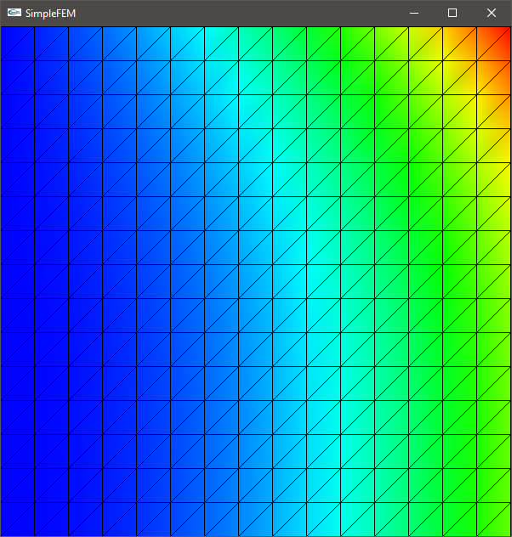

gridSize = 16; gradedMesh = false; laplaceProblem = false;

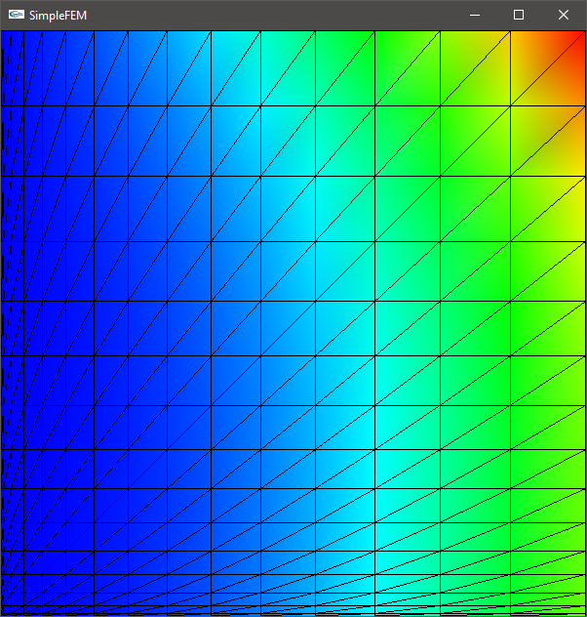

gridSize = 16; gradedMesh = false; laplaceProblem = false;

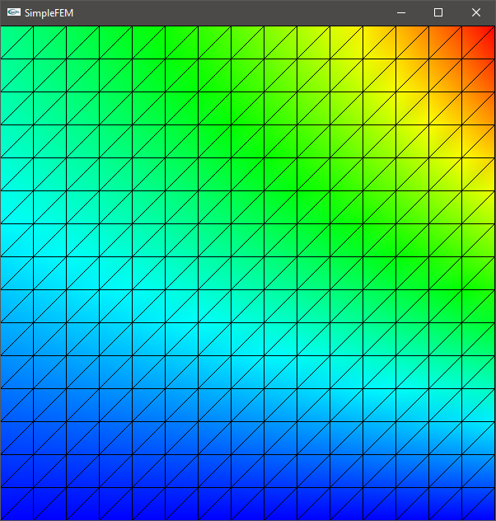

gridSize = 16; gradedMesh = false; laplaceProblem = true;

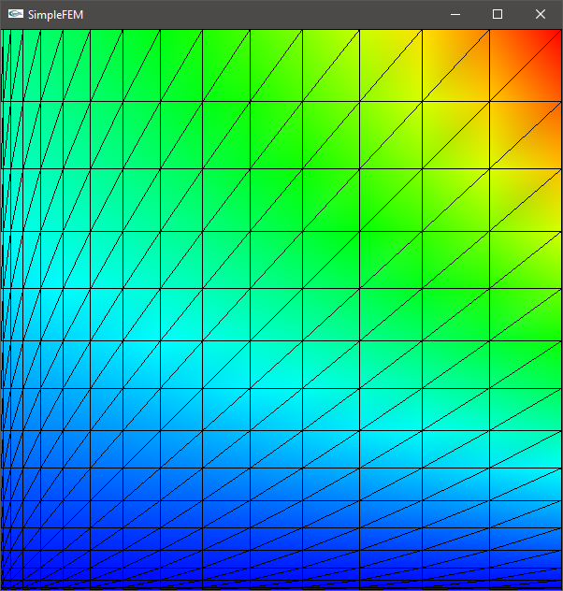

gridSize = 16; gradedMesh = true; laplaceProblem = true;